

Practices for Secure Software Report

Table of Contents
Document Revision History 3
Client 3
Instructions 3
Developer 4
1. Algorithm Cipher 4
2. Certificate Generation 4
3. Deploy Cipher 4
4. Secure Communications 4
5. Secondary Testing 4
6. Functional Testing 4
7. Summary 4
8. Industry Standard Best Practices 4

Document Revision History

Version | Date | Author | Comments
1.0 | 02/24/2026 | Jarod Jecas

Client



Instructions

Submit this completed practices for secure software report. Replace the bracketed text with the relevant information. You must document your process for writing secure communications and refactoring code that complies with software security testing protocols.

- Respond to the steps outlined below and include your findings.
- Respond using your own words. You may also choose to include images or supporting materials. If you include them, make certain to insert them in all the relevant locations in the document.
- Refer to the Project Two Guidelines and Rubric for more detailed instructions about each section of the template.

Developer
Jarod Jecas

Algorithm Cipher

For this project I used the SHA-256 hashing algorithm to produce a checksum value. SHA-256 will produce a 256-bit hash value that is represented by 64 characters in hexadecimal. Hashing algorithms are commonly used throughout industry to verify that data is unchanged because they cannot be reverse engineered or knowingly collided with. I built the SHA-256 algorithm into my Spring Boot application to allow for user input to be hashed and verified without actually storing the original input.

Certificate Generation

I created a self-signed certificate using Java's keytool utility. Saved this certificate as PKCS12 keystore file (keystore.p12) and exported as a .cer file. Certificate allows HTTPS communication between client browser and Spring Boot server. Below screenshot displays successful generation and export of certificate file.

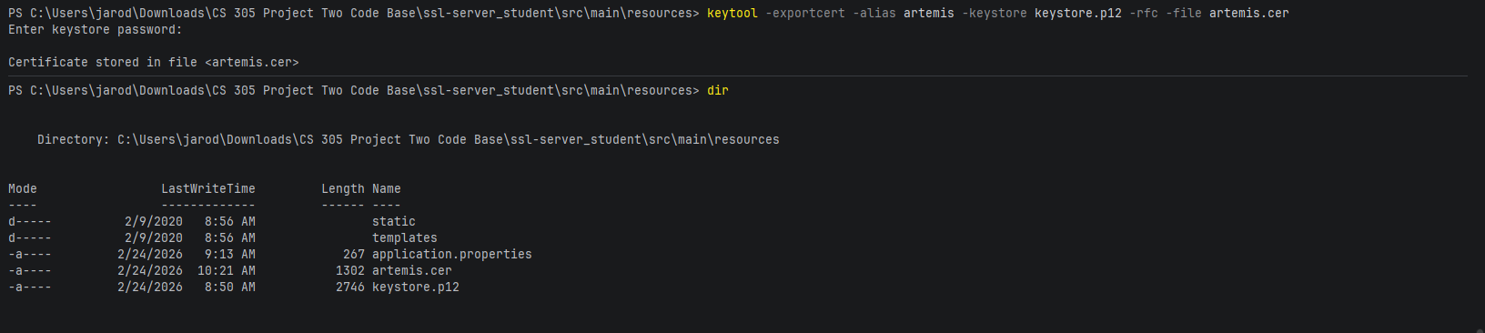

Deploy Cipher

I implemented the SHA-256 hash function inside of the Spring Boot application through a REST controller. The /hash endpoint takes user input and outputs a SHA-256 checksum. Once the cipher was deployed, I tested to ensure the endpoint produced the correct hash output through my browser.

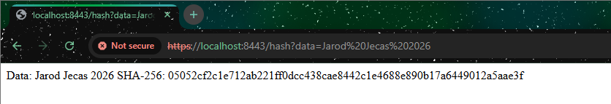

Secure Communications

I set the application up to serve HTTPS content on port 8443 using the provided keystore. Now the client/server traffic is encrypted. Yes the certificate is self-signed (hence the browser warning) but at least the traffic is encrypted with SSL/TLS. Below is a screenshot of the app running with HTTPS.

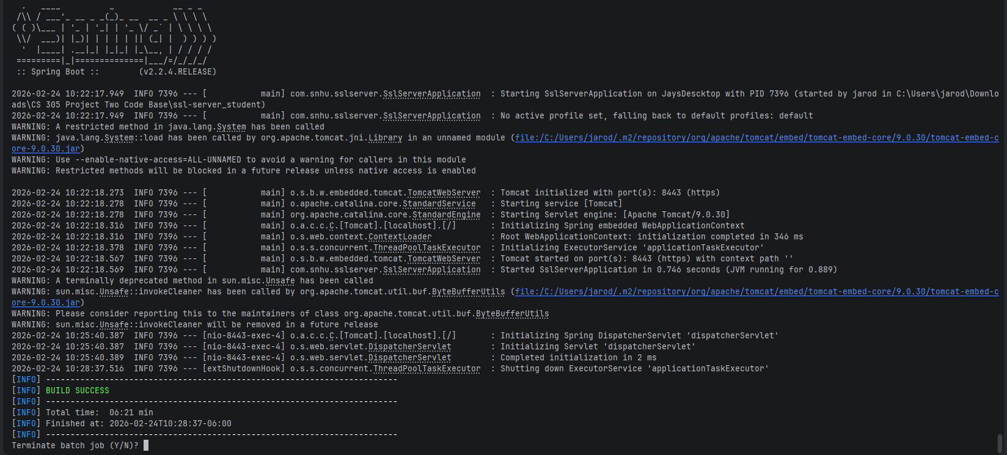

Secondary Testing

I executed OWASP Dependency-Check version 12.1.0 and analyzed the project's third party dependencies to identify known vulnerabilities. The tool finished executing and created an HTML report of it's findings. There were multiple vulnerabilities found due to outdated dependencies. Most of these vulnerabilities existed in Spring Boot version 2.2.4.RELEASE along with it's internal dependencies such as Tomcat, Jackson, SnakeYAML, Hibernate Validator, Log4j. The severity of these vulnerabilities stresses why dependencies should be kept up-to-date with security patches.

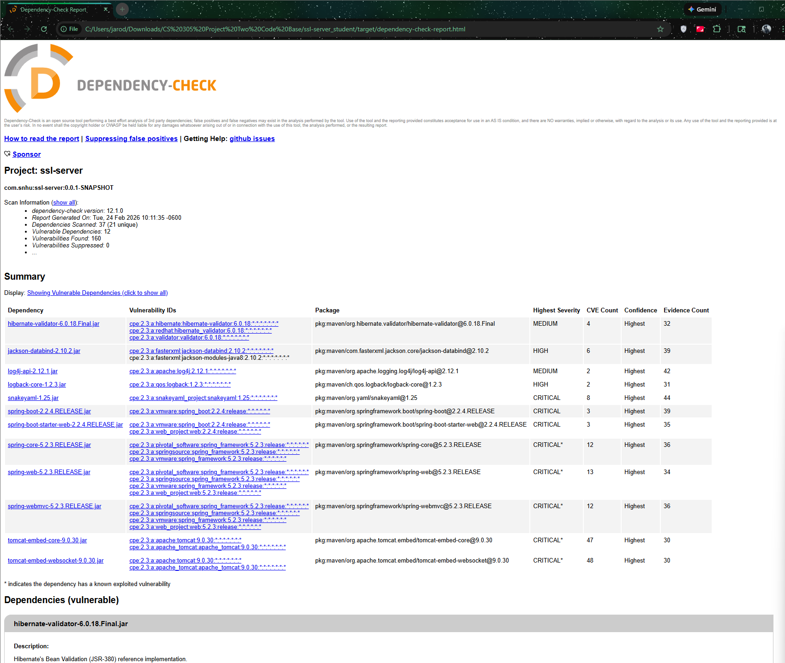

Functional Testing
Having added secure communications and the hashing endpoint, I verified that all aspects of the application ran without error during execution. I found that my application can:

Run over HTTPS

Accept user input

Create SHA-256 hashes

Load without errors

Perform dependency analysis

Since my application built and ran correctly, I can conclude that it is operating properly.

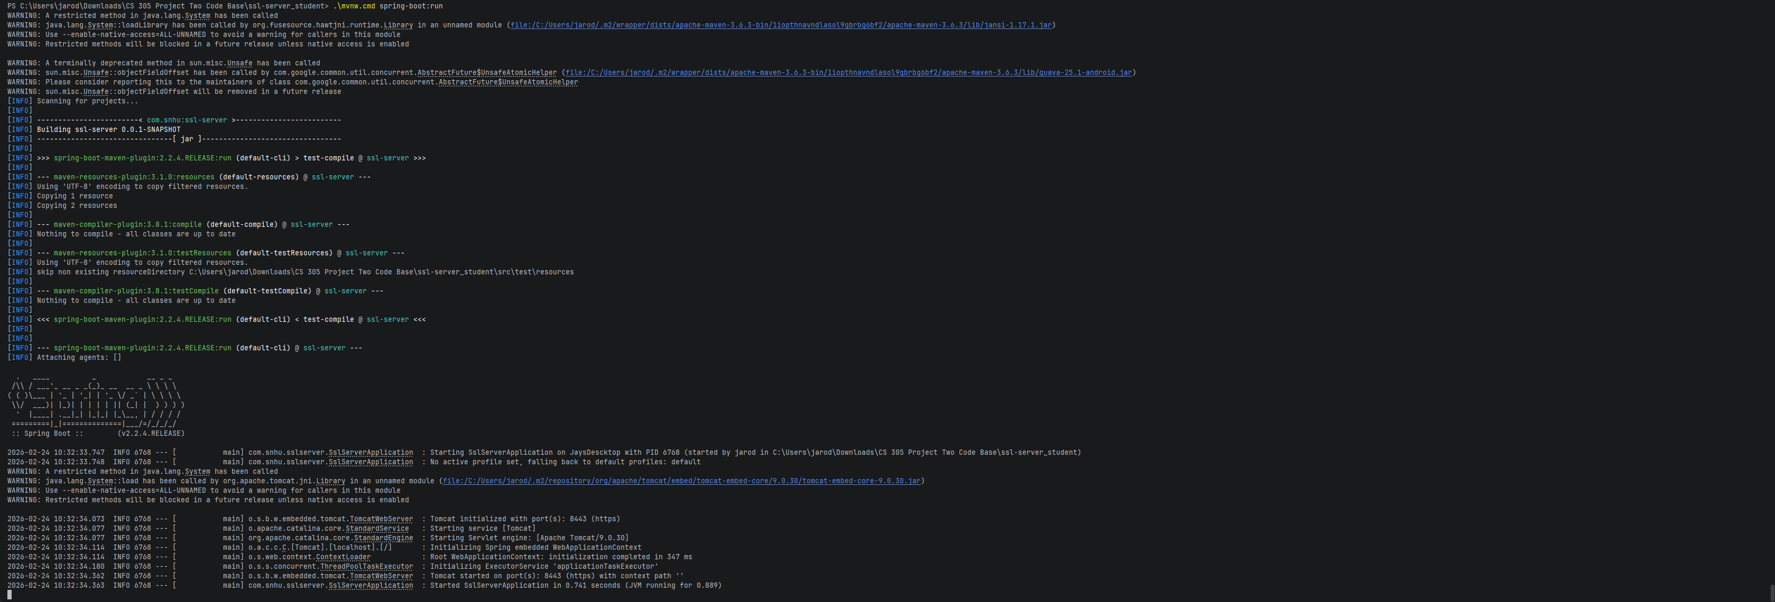
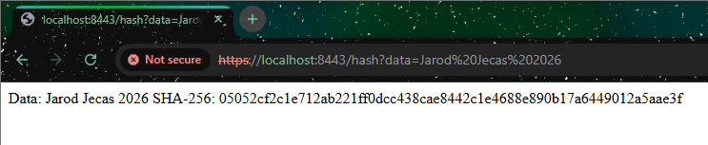

Summary
For this project, I created hashing functionality using cryptography. Created and utilized self-signed certificates and secured connections with HTTPS. Finally completed static analysis with OWASP Dependency-Check. Analysis showed that secure code practices were used and the site is running through HTTPS. However, when utilizing Dependency-check we were able to find that previous versions of the framework had some vulnerabilities.

Industry Standard Best Practices
Security practices used in this project include:

SHA-256 for hashing passwords

HTTPS for secure socket layer connections

PKCS12 keystore to manage certificates

OWASP Dependency-Check for dependency analysis

Storing application config outside of source directory

Functional and security testing for validation

These are all recommended Secure Software Development Lifecycle (SDLC) and OWASP security best practices.

